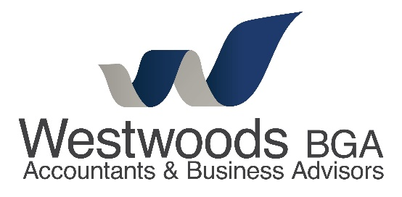
Client Case Study
Growing business in need of tax savings

“We never knew you could use a ‘bucket company’ to save tax nor many of the other strategies Westwoods BGA went through with us. The tax savings in the first year alone have been amazing!”

Background
Our clients, Tim and Lisa (not their real names) run a very successful retail business and have been profitable now for many years. Thinking that paying tax was just a necessary by-product of profit, they were paying more than their fair share for many years and wondered whether there was any way of legitimately reducing this. In addition, tax payments were taking a big chunk of their disposable income therefore making it near impossible to save money or put funds away for their retirement. Being in one of our service packages gives them the benefit of meeting with us on a quarterly basis and us proactively reviewing their situation. It was one such meeting which uncovered this tax planning opportunity. Following this meeting we undertook some analysis then presented our solution and, as you will see, working together we built a custom-made plan to get them on their way.
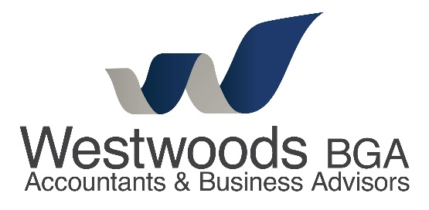
Growing business in need of tax savings

How we helped
By doing a needs analysis and fact find with our clients and asking some quality questions we were able to find out exactly what our clients wanted to achieve and importantly, by when. This work included looking at the possible trade-off between simply paying the tax or paying the interest if this put them into an overdraft situation – some very delicate work indeed! Then using our state-of-the-art Tax Plan software we built four different strategies for them to achieve their goal. Eventually settling on our ‘bucket company’ strategy together with making maximum super contributions, Tim and Lisa are well on their way to saving tax whilst also growing their retirement nest egg. The bucket company strategy enables them to cap the tax paid on any profits distributed to the company at the company’s tax rate, namely 26% instead of the top marginal rate of tax of 47% - a huge advantage.

The outcome
Tim and Lisa secured a whopping $39,207 in tax savings in the first year. Looking back, they now realise how easy and cost effective the whole process was as we managed it from start to finish. The beauty of using this or any other strategy (and there are over 80 to choose from!) is they can be used year after year, making tax savings an annual event and a normal part of one’s year-end routine.
Happily too, Tim and Lisa have been able to go away on that long awaited holiday and upgrade their family vehicle due to the tax savings they have made to date.

“The team at Westwoods BGA handled it with minimal fuss and cost effectively. We are now busy planning our next holiday!”

Westwoods BGA Accountants & Business Advisors
211 Grange Road, Findon SA 5023
08 8243 8700
info@westwoodsbga.com.au

